# Early aviation accident data analyzing

* What was the total number of fatalities in accidents each year?

SELECT Year, SUM(Fatalities) AS ' Total Fatalities each year'

FROM airline_DB

GROUP BY Year

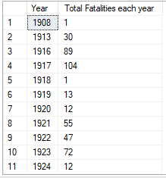

---Top years for highest fatalities incidents

SELECT TOP 5 YEAR, SUM(Fatalities) AS 'Top Highest Fatalities'

FROM airline_DB

GROUP BY Year ORDER BY SUM(Fatalities) desc;

* How many accidents occurred in military vs civilian flights?

SELECT

SUM(CASE WHEN Operator LIKE 'Military%' THEN 1 ELSE 0 END) AS Military_Accidents,

SUM(CASE WHEN Operator NOT LIKE 'Military%' THEN 1 ELSE 0 END) AS Civilian_Accidents

FROM airline_db

* What was the accident with the highest number of fatalities?

SELECT TOP 3 * FROM airline_DB

ORDER BY Fatalities Desc



* --Which aircraft models were involved in more than one accident?

SELECT Registration,COUNT(*) AS 'Aircraft Model'

FROM airline_DB

GROUP BY Registration

HAVING COUNT(*)>1 ORDER BY COUNT(*) Desc

* What was the deadliest aviation accident in terms of both onboard and ground fatalities?

SELECT TOP 1 *,(Aboard + Ground) AS 'Total_Fatalities'

FROM airline_DB

ORDER BY Total_Fatalities Desc



* Deadliest aviation accident in respective of fatalities?

SELECT TOP 1 * FROM airline_DB

ORDER BY Fatalities Desc





* How many accidents involved airships (Zeppelin), and what was their average number of fatalities?

SELECT COUNT(*) AS 'Total Airship Accident',

avg(Fatalities) AS 'Average Fatalities'

FROM airline_DB

WHERE Type LIKE '%Zeppelin%'



* Which operator had the highest number of accidents, and what was the most common aircraft type they operated?

SELECT TOP 5 Operator,

COUNT(*) AS 'number of accidents',

MAX(Type) As 'Aircraft Type'

FROM airline_DB GROUP BY Operator ORDER BY COUNT(*) Desc

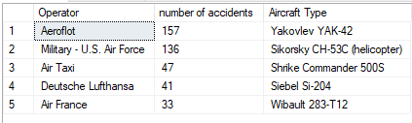

* What was the most common location for aviation accidents in the dataset?

SELECT TOP 1 Location,

COUNT(*) AS 'Total Accidents',

DENSE_RANK() OVER (ORDER BY COUNT(*) Desc) AS 'Accident_Rank'

FROM airline_DB

GROUP BY Location ORDER BY [Total Accidents] Desc



* How many accidents involved Airbus aircraft?

SELECT COUNT(*) AS 'Total Airbus Accidents'

FROM airline_DB

WHERE Type Like '%Airbus%'



* Which year had the highest number of aviation accidents?

SELECT TOP 1 Year, COUNT(*) As 'Highest Accidents'

FROM airline_DB

GROUP BY Year ORDER BY COUNT(*) Desc



* How many accidents occurred during test flights?

SELECT COUNT(*) AS 'Total Test Flight Accidents'

FROM airline_DB

WHERE Summary Like '%test% flight%'

